**Duck Master**

A Level PipeLine Assessment

So I hear that you want to implement a new level? Great news then this document will show a step by step introduction of how to implement your new level!

**Set Up**

What makes up a level? There are several ingredients to make this work. First you need to copy the test level scene and rename it to

*“Level_(number)”*. The test level is where the most recently update level build requirements are set in place so you don’t need to redo all those annoying values.

Now whats next? Of course you need the level data so navigate to *Assets/LevelDataFolder* and copy TestLevel and rename it to

*“Level_(number)”*. Then rename both level.png file and special file to something like level_2 something. This way a user won’t be confused with same names of levels if all the png files are named the same. Also get rid of the meta files.

Finally to have the assets working, open up Unity and navigate to the scene. Click on the level png and make sure that in the advanced settings that Read/Write is **checked** and Non Power of 2 is **None**

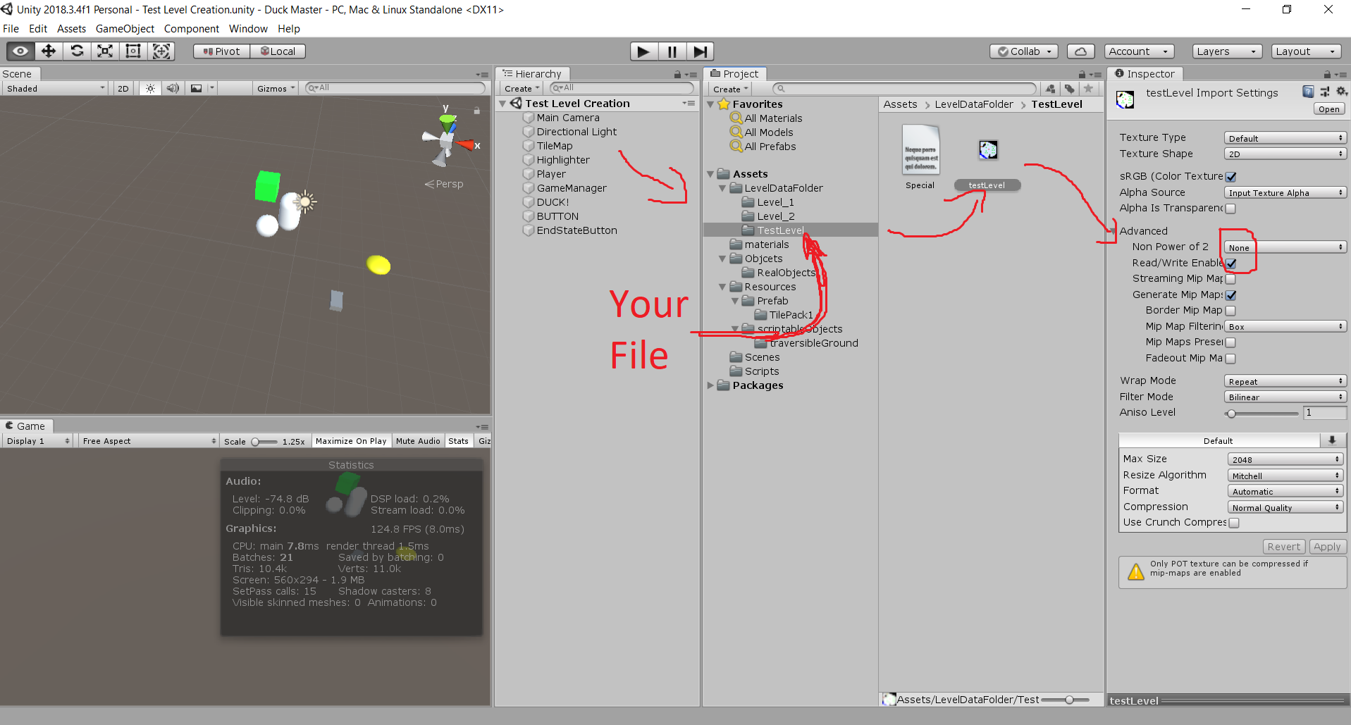

Congrats! Your scene should be working now.

**Customizing the level Size**

Now there are a few things you can change. In the hierarchy, click on TileMap and fit the size X and size Z to the right size of your png file. You can change the size of the png file in the properties in paint.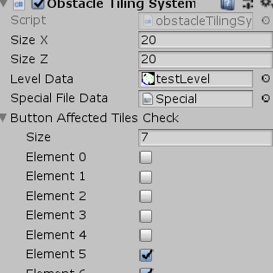

**Building your Level**

So now what? Now you build your level, how this works is the unity will read that png file pixel by pixel. Each color of that pixel translates to a tile in game. There is a text file in *Assets/LevelDataFolder* that will tell you each tile, what it does, and the color values. Now pick a tile color and draw out your new level!

Let’s say you want to place a water tile, look what the color for the water tile is which will be (0,0,255). Now go to paint and add new color:

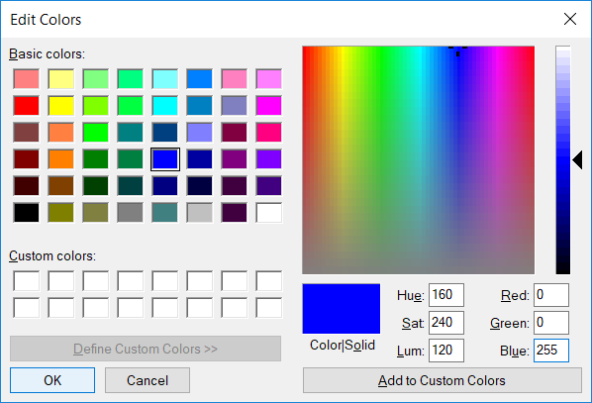

Note: Now make sure that the color values are exact otherwise the unity reader won’t recognize that color to tile and will fail to generate it.

Once you picked your color, draw!

(Don’t forget to use the pencil tool)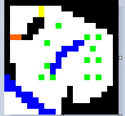

**Specials**

Once you’ve finished with that, now do not forget that there is also special elements in the game. A special will is an entity in the game that does not follow tile rules like an unfriendly or button. These will be in the specials file. To create a new special, go to the tileMap and navigate to find the specials list, I will be adding a text file explaining each special and their index. Each special will have an index, that is what you need to spawn in the special. So it starts like this:

Index: 1 posX: 4 posZ: 16 unfriendly

The word index, posX, posZ just indicates what those numbers mean. The **1** means it is special type 1, the positions can be derived from paint at the lower left of the screen.

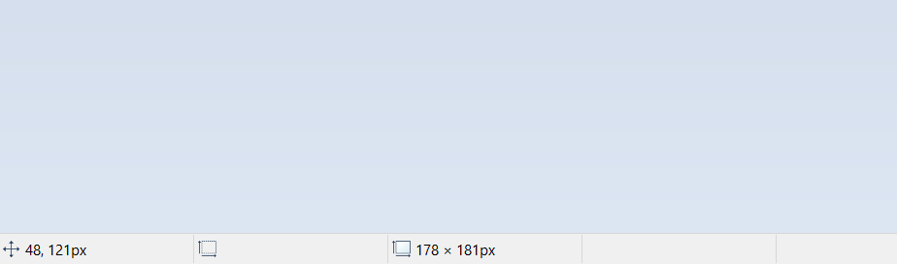

This number will be your coordinates where ever you hover your mouse over at which currently says 48,121.

The first number 48 is the X position. The second number 121 is not the Z position but is inverted so you’ll need to calculate it by this equation:

Ysize - second number = Z position.